Pre-Columbian forest gardens span 180 km² in Bolivia’s Iténez preserve

Abstract

The Iténez Forest Preserve in the Bolivian Amazon spans 4,000 km² between two of South America’s most significant archaeological landscapes—yet until now it remained unmapped, a blank spot between lowland Bolivia and the Brazilian Amazon. Using satellite imagery from the driest months on record and an AI-assisted detection system, I identified 180 km² of anthropogenic soils and forest gardens across the preserve. These features, connected by dense networks of earthworks that remain to be fully mapped, reveal organized landscape modification on a scale comparable to the region’s famous earthwork complexes. The findings demonstrate how ancient peoples transformed rainforest into productive cultural landscapes whose ecological signatures persist today, with local communities continuing to harvest cacao and other useful species from these anthropogenic forests. This work illustrates how AI can support—but not replace—human expertise in archaeological detection at regional scales.

Source: [Article Notebook](https://nick-gauthier.github.io/itenez-anthrosols/index-preview.html)

## Introduction

For decades, a 4,000 km² void has persisted in archaeological maps of the Amazon, separating the well-studied earthwork landscapes of Bolivia from the forests of the Brazilian Amazon. The Iténez Forest Preserve occupies this glaring gap along the Bolivia-Brazil border. Located along the Bolivia-Brazil border between the extensively studied earthwork landscapes of the Bolivian lowlands and the forests of the Brazilian Amazon, this 4,000 km² expanse of forest remained largely unmapped by archaeologists. While important studies have documented sites at the preserve’s northern and southern margins (Robinson et al. 2021; Prümers, Jaimes Betancourt, and Plaza Martinez 2023; Carson et al. 2016) , the rugged interior—the vast majority of this territory—has remained archaeologically unknown. Dense canopy cover, remoteness, and lack of prior survey work in the interior left it a blank spot on regional maps—a void in our understanding of southwestern Amazonian prehistory. Its position between known centers of pre-Columbian engineering (Peripato et al. 2023; De Souza et al. 2018), however, suggested it might hold similar evidence of ancient landscape modification.

This study fills that gap through systematic remote sensing analysis, revealing extensive anthropogenic landscapes hidden beneath the forest canopy. The work focuses specifically on detecting Amazonian Dark Earth (ADE) and associated forest gardens—patches of modified forest composition that mark ancient settlements and agricultural areas (Schmidt et al. 2014; Palace et al. 2017; Goldberg et al. 2024) . While earthworks are noted where visible, comprehensive mapping of these features beneath the canopy remains for future work. This approach prioritizes the detection of anthropogenic soils and forest composition changes that represent the primary evidence of human landscape transformation in continuously forested regions.

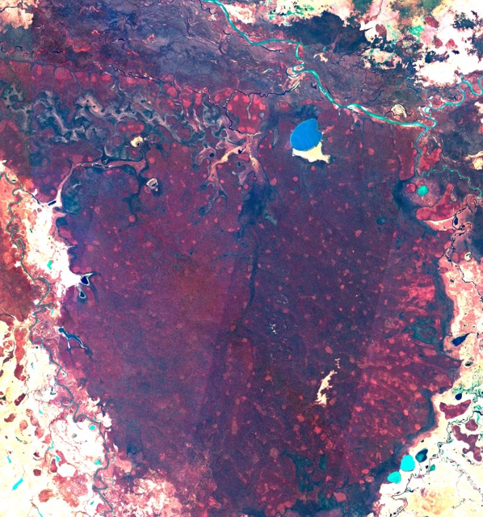

Sentinel-2 false color image composite of Itenez Forest Preserve from summer 2023. Light red spots indicate drier , lowcanopy vegetation associated with anthropogenic forest gardens (palms, cacao, bamboo, and other economically useful plants).

The detection of these features at regional scale required developing new methodological approaches that combine AI-assisted pattern recognition with expert archaeological interpretation—a partnership where computational tools support but do not replace human expertise in identifying and mapping cultural landscapes.

## Methods

### Image Selection and Processing

I selected Sentinel-2 imagery (European Union/ESA/Copernicus 2017) from the driest periods in the satellite record (late summer 2023 and 2024), when reduced vegetation moisture and seasonal leaf loss maximize visibility of underlying soil and vegetation patterns. Cloud-free mosaics were processed in Google Earth Engine, combined with a state of the art regional canopy height model (Wagner et al. 2025) to distinguish anthropogenic forest structures from natural variation.

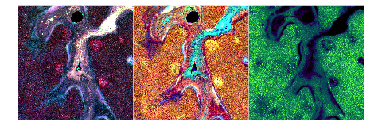

False color Sentinel 2 image chips (left, center) and canopy height estimate (right). Anthropogenic forest patches appears as rounded patches of dry, low-canopy vegetation along terraces. Faint traces of earthworks and ditches can be seen surrounding and connecting the forest patches.

Source: [Article Notebook](https://nick-gauthier.github.io/itenez-anthrosols/index-preview.html)

The imagery was exported as multi-scale tiles (512, 768, and 1024 pixels) with band combinations optimized to highlight spectral signatures of ADE and modified forest. These signatures reflect the distinct ecological characteristics of anthropogenic landscapes: more open canopy structure, seasonal deciduousness, high concentrations of useful plants (palms, bamboos, cacao), and altered soil chemistry from centuries of human occupation and management Robinson et al. (2021).

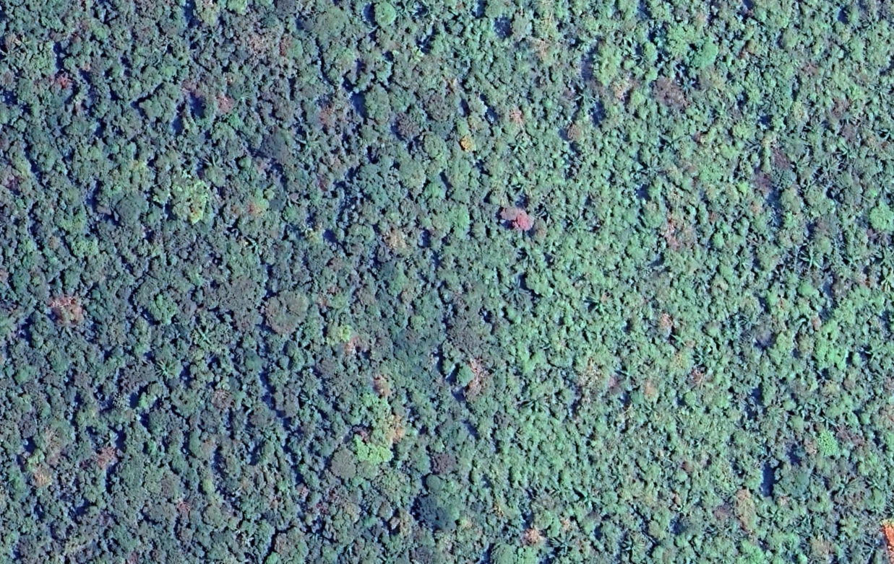

Detail of transition between natural forest vegetation (left) and anthropogenic forest (right). Not the lighter vegetation, lower canopy, and preponderance of palms and lianas.

### Detection Workflow: Human-AI Partnership

I developed an agentic object detection system using GPT-4.1, and Moondream2 vision-language models to identify anthropogenic features at scale. This system serves as a detection and verification tool, supporting human expertise rather than replacing it. The workflow operates as follows:

1. GPT models review imagery and generate initial hypotheses about feature locations based on spectral patterns and landscape context. They are prompted to view the landscape holistically, looking for patterns across multiple domains, rather than focusing on strict quantitative criteria.
2. The primary models iteratively refine predictions through successive passes using a smaller, specialized vision language models tuned for object detection and grounding. These system lack the domain knowledge of the image contents, so the GPT agent must generate creative, abstract text prompts to detect all features in the scene (e.g. “reddish-pink spots”, “purple swirls”.
3. The system produces point predictions marking potential anthropogenic sites
4. These points guide large-scale verification and exploration of spatial patterns

**Examples:**

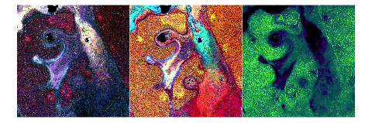

Source: [Article Notebook](https://nick-gauthier.github.io/itenez-anthrosols/index-preview.html)

**Scene interpretation (Step 1):**  
  
- **C1:** The image shows a continuous forest matrix with several compact,   
lobate, and elliptical reddish-pink/magenta patches, especially in the lower   
left, lower center, and upper center. These patches are surrounded by darker,   
more mottled forest. Some patches are ring-like or clustered, with faint linear  
connections or edges.  
- **C2:** The same areas correspond to bright yellow/orange splotches,   
supporting the presence of stressed/drier vegetation typical of ADE patches.   
The yellow/orange zones are compact and match the reddish/magenta patches in   
C1.  
- **CHM:** The canopy height map shows some of these patches as lower-canopy   
areas (purple/blue), sometimes with ring-like or edge effects, further   
supporting the interpretation as ADE patches.  
  
**Spatial context:** The anomalies are within a continuous forest, not at a   
forest/nonforest boundary. The form is compact, not diffuse, and several   
patches are ≥5 ha. There are also hints of linear features (possible   
earthworks) connecting or bordering some patches.  
  
**Initial expert estimate:** There are at least 3–5 valid ADE patch candidates   
in this scene, possibly more depending on how some of the more irregular   
patches are counted.  
  
**Proceeding to Moondream object detection (Step 2).**  
  
**First tool prompts:**  
- "reddish-pink spots"  
- "magenta patches"  
  
Running these in parallel to capture the main compact anomalies.

**Synthesis of Moondream results (Step 3):**  
  
- Both prompts ("reddish-pink spots", "magenta patches") returned highly   
overlapping sets of points, confirming the main compact anomalies.  
- After removing redundant points (duplicates within a few pixels), there are 7  
distinct compact patches:  
 1. (0.0918, 0.2998) — Lower left, compact, strong dual spectral support, low   
canopy.  
 2. (0.292, 0.8223) — Lower center, compact, strong dual spectral support, low  
canopy.  
 3. (0.4375, 0.7656) — Lower center-right, compact, strong dual spectral   
support, low canopy.  
 4. (0.6309, 0.5967) — Center-right, compact, strong dual spectral support,   
low canopy.  
 5. (0.7344, 0.1084) — Upper right, compact, strong dual spectral support, low  
canopy.  
 6. (0.8486, 0.3789) — Right edge, compact, strong dual spectral support, low   
canopy.  
 7. (0.9678, 0.6709) — Far right edge, compact, strong dual spectral support,   
low canopy.  
  
- All points are within continuous forest, have compact form, and are supported  
by both C1 and C2, with CHM showing low canopy or edge effects.  
  
**Summary of synthesis:**  
- 7 distinct ADE patch candidates identified.  
- All have strong dual spectral support and compact form.  
- No points are redundant or outside the valid context.  
- No diffuse or boundary-only anomalies included.  
- All patches are ≥5 ha and fit the expected spatial pattern.  
  
DONE.

Source: [Article Notebook](https://nick-gauthier.github.io/itenez-anthrosols/index-preview.html)

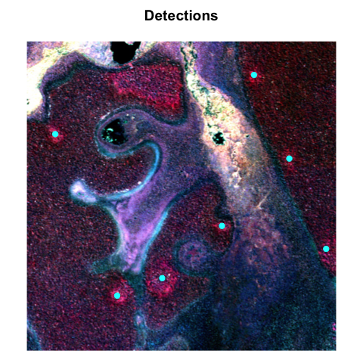

Source: [Article Notebook](https://nick-gauthier.github.io/itenez-anthrosols/index-preview.html)



Source: [Article Notebook](https://nick-gauthier.github.io/itenez-anthrosols/index-preview.html)

**Scene interpretation (Step 1):**  
  
- **Context:** The scene is mostly continuous forest matrix with some   
branching, bluff-edge-like features and a few compact, lobate,   
reddish-pink/magenta patches in C1. These patches are not simply   
forest-nonforest boundaries; they are embedded within the forest matrix, not at  
the edge of clearings or floodplain.  
- **Spectral-structural combo:**   
 - **C1:** Several compact, bright reddish-pink/magenta patches (not diffuse,   
not isolated tiny blobs), especially in the upper right quadrant and near the   
center-right.   
 - **C2:** These same areas correspond to yellow/orange splotches, supporting   
the interpretation as stressed/drier vegetation.  
 - **CHM:** Some of these patches show subtle lower-canopy signals, but not   
all are strongly expressed in CHM.  
- **Form:** The anomalies are compact, mostly round to lobate, and ≥5 ha in   
size.  
- **Exclusions:** The large dark/black areas are likely water or deep canopy   
gaps, not ADE patches. The branching pale features are likely drainage or bluff  
edges, not ADE.  
  
**Initial expert estimate:** 3–5 plausible ADE patch candidates (upper right,   
center-right, and possibly one or two more faint ones).  
  
Proceeding to Moondream object detection for precise point locations.

**Synthesis of Moondream points:**  
  
- Both prompts ("reddish-pink spots", "magenta patches") returned nearly   
identical sets of points, confirming the main compact anomalies.  
- After removing redundant points (duplicates within a few pixels), there are 7  
distinct compact patches.  
- All selected points correspond to compact, lobate, reddish/magenta anomalies   
in C1, with supporting yellow/orange in C2, and are embedded within the forest   
matrix—not at forest-nonforest boundaries.  
- Most patches are ≥5 ha and have plausible ADE form/context.  
- No points are in obvious recent clearings, floodplain, or non-forest.  
  
**Summary:** 7 distinct ADE candidate patches detected.   
DONE.

Source: [Article Notebook](https://nick-gauthier.github.io/itenez-anthrosols/index-preview.html)

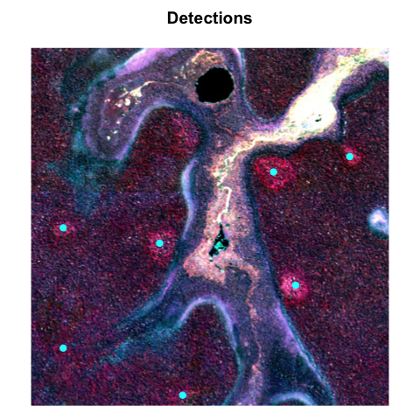

Source: [Article Notebook](https://nick-gauthier.github.io/itenez-anthrosols/index-preview.html)

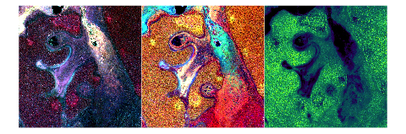

Source: [Article Notebook](https://nick-gauthier.github.io/itenez-anthrosols/index-preview.html)

**Scene interpretation (Step 1):**  
  
- **C1:** Several compact, lobate, reddish-pink/magenta patches are visible,   
especially in the lower center, lower right, and mid-left of the image. These   
stand out against the mottled forest matrix and are not simply forest-nonforest  
boundaries.  
- **C2:** These same areas correspond to bright yellow/orange splotches,   
indicating low transpiration (drier, stressed vegetation), supporting the ADE   
patch hypothesis.  
- **CHM:** The same locations show as compact, slightly lower-canopy patches or  
rings, further supporting the interpretation as anthropogenic ADE patches   
rather than recent disturbance or natural forest variation.  
  
**Spatial context:** The patches are distributed in a clustered, patterned   
manner, some aligned along subtle drainage lines, consistent with known   
ADE/terra preta settlement patterns. No evidence of recent sharp land-use   
mosaics or clearings.  
  
**Initial expert estimate:** There are approximately 8–10 valid ADE patch   
candidates in this scene.  
  
**Proceeding to Moondream object detection (Step 2):**  
I will start with two prompts to capture the main spectral signature:  
- "reddish-pink spots"  
- "large magenta patch"  
  
Running both in parallel for robust detection.

**Synthesis (Step 3):**  
  
- The "reddish-pink spots" prompt returned 12 points, and "large magenta patch"  
returned 1 additional point (which overlaps with an existing detection).  
- After removing redundant/overlapping points and validating each for   
compactness, dual spectral support, and context, I confirm that 10 of these   
points correspond to distinct, compact ADE-like patches (≥5 ha), all with   
strong support in C1, C2, and CHM.  
- Points at the extreme image edge (upper left) are excluded due to   
insufficient context.  
- All selected patches are within continuous forest, not at forest-nonforest   
boundaries, and show the expected spectral-structural pattern.  
  
**Summary of synthesis:**  
- 10 distinct ADE patch candidates identified.  
- All show compact, lobate form, dual spectral support, and CHM anomaly.  
- No evidence of recent disturbance or non-forest context.  
- Points are spatially patterned, consistent with ADE settlement systems.  
  
DONE.

Source: [Article Notebook](https://nick-gauthier.github.io/itenez-anthrosols/index-preview.html)

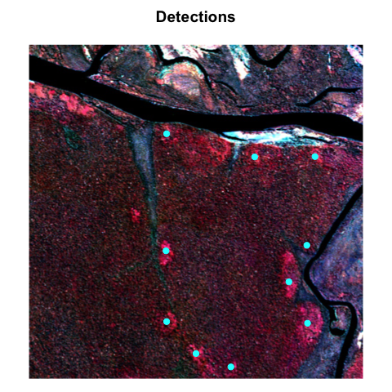

Source: [Article Notebook](https://nick-gauthier.github.io/itenez-anthrosols/index-preview.html)

Critically, this AI component operated in parallel with detailed manual mapping. I meticulously reviewed and labeled hundreds of polygon boundaries over anthropogenic forest patches through careful imagery analysis, with the AI and manual mapping developing iteratively and informing each other. Earthworks—canals, ditches, and geometric earthworks—were recorded where visible through the canopy, though comprehensive mapping of these linear features remains a priority for future work with higher-resolution imagery. This approach allowed me to iteratively calibrate and validate the models’ ability to detect known archaeological features in zero-shot and few-shot learning contexts. The models were not fine-tuned but leveraged pre-trained capabilities to recognize visual patterns consistent with archaeological features. This approach exemplifies how AI can extend human capacity for regional-scale analysis without replacing the expertise necessary for accurate feature identification and interpretation.

## Results

The analysis **identified approximately 180 km² of anthropogenic soils and forest gardens within the Iténez Forest Preserve, representing 5% of its total area—comparable to the footprint of many modern world cities**, though distributed as a network of patches rather than a contiguous area. I mapped over 350 individual fields ranging from 5 to 700 hectares, with clear spatial clustering along bluffs, drainages, and floodplain margins in upland *terra firme* forest—confirming hypotheses about bluff-edge settlement systems previously proposed for this region (Denevan 1996).

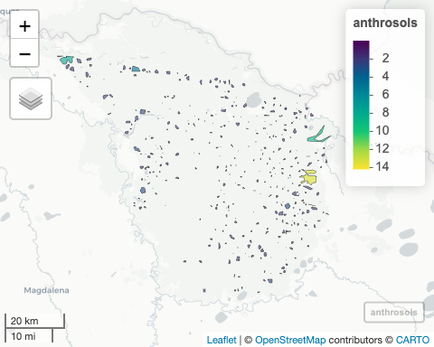

Anthropogenic forest patches.

|---------|---------|---------|---------|  
=========================================

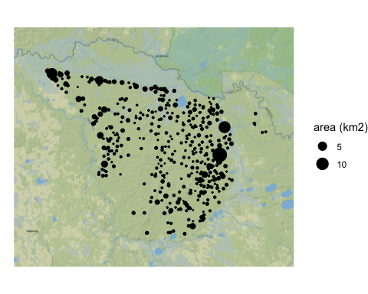

Anthropogenic forest patches.

Source: [Article Notebook](https://nick-gauthier.github.io/itenez-anthrosols/index-preview.html)

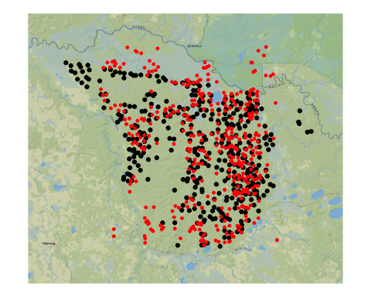

Manually labeled site locations (black) compared to automatically detected locations (red).

Source: [Article Notebook](https://nick-gauthier.github.io/itenez-anthrosols/index-preview.html)

The most striking discovery is a major complex spanning more than 4 kilometers, where large-scale fields connect through networks of earthworks. Across the mapped area, an exceptionally dense system of linear features links settlements into an integrated landscape. While full mapping of these earthworks awaits future work with canopy-penetrating sensors, their visible portions already demonstrate a level of landscape integration comparable to the most complex sites in neighboring regions.

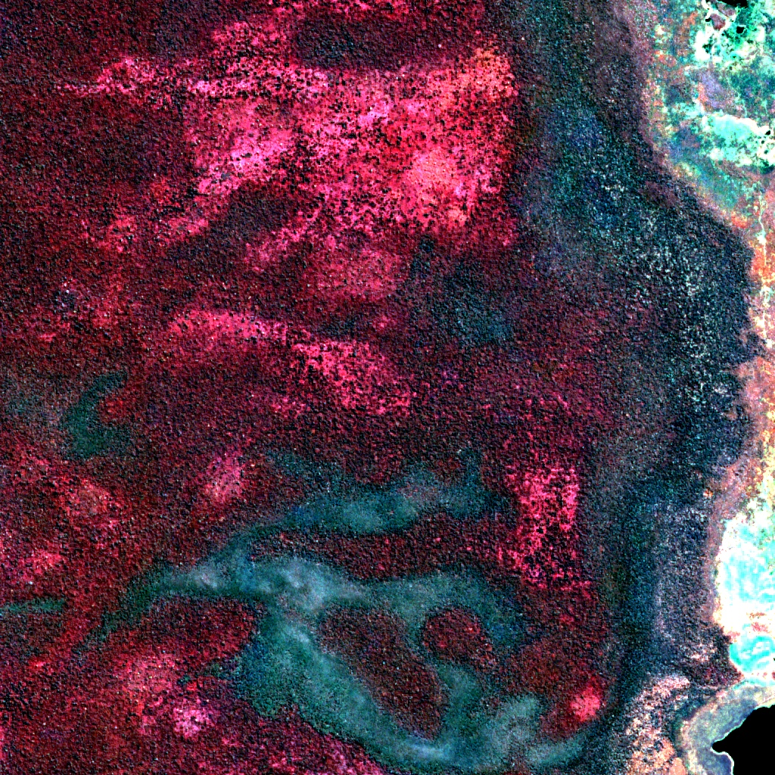

Rank-size analysis reveals a clear hierarchical structure in field sizes and site distribution, with the size distribution following a power law with an exponent close to 1 on log-log plots. This pattern, consistent with organized settlement systems, matches the scale and complexity documented in the Llanos de Mojos and Baures (Prümers et al. 2022; Erickson 2000). The largest sites anchor networks of settlement and agroforestry patches, suggesting centralized planning and resource management across the landscape.

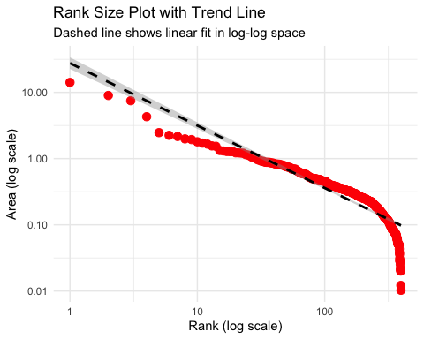

Source: [Article Notebook](https://nick-gauthier.github.io/itenez-anthrosols/index-preview.html)

These anthropogenic landscapes remain ecologically distinct today. Forest composition in mapped areas shows high concentrations of economically useful species, particularly cacao, making the region a modern hotspot for wild cacao cultivation—a direct legacy of ancient land use practices (Carson et al. 2016) . Local and Indigenous communities continue to harvest these resources, underscoring that these are not merely archaeological sites but living landscapes where ancient management practices continue to shape both forest ecology and human livelihoods.

## Discussion

These findings transform our understanding of the Iténez region from archaeological blank spot to critical piece in the Amazonian puzzle. The extent and organization of anthropogenic landscapes documented here match or exceed those in better-studied areas, confirming that large-scale landscape engineering extended continuously across the southwestern Amazon. This fills the last major gap in the regional archaeological map between the Llanos de Mojos and Baures, revealing that the Iténez was not a periphery but an integral part of pre-Columbian regional systems.

The hierarchical site structure and extensive earthwork networks point to complex social organization capable of coordinating landscape modification across thousands of square kilometers. Rather than isolated communities practicing small-scale agriculture, the evidence suggests integrated regional systems linking settlements through engineered infrastructure and shared land management practices. The concentration of sites along bluff edges and floodplain margins confirms earlier hypotheses about settlement preferences in *terra firme* forests, while the scale revealed here exceeds previous expectations.

The ecological legacy of these ancient landscapes extends beyond their archaeological significance. Forest composition in mapped areas reflects centuries of human selection for useful species, creating patches of anthropogenic forest that blur the line between nature and culture. The continued harvesting of cacao and other products from these forests by contemporary communities represents an unbroken tradition of forest management extending from pre-Columbian times to the present. This continuity challenges us to recognize that the “pristine” forests we seek to conserve are themselves products of Indigenous innovation and management.

The successful detection of these features through combined AI and expert analysis demonstrates new possibilities for archaeological survey in forested regions. The human-AI partnership developed here—where computational tools assist in pattern detection while human expertise guides interpretation and mapping—offers a model for scaling archaeological survey across Amazonia’s vast forests. This approach proved particularly effective for identifying the subtle spectral signatures of anthropogenic soils and forest gardens that would be impossible to map at this scale through ground survey alone.

### Implications and Future Directions

This work contributes to the mounting evidence that the Amazon was extensively shaped by its pre-Columbian inhabitants, adding a major piece to our understanding of regional cultural landscapes. The Iténez landscapes join the growing inventory documented by recent synthetic works, while demonstrating that significant discoveries remain to be made even in the 21st century. The findings reinforce emerging models of pre-Columbian Amazonia as a mosaic of engineered landscapes rather than pristine wilderness punctuated by occasional cultural sites.

Future research should pursue several directions. First, LiDAR or high-resolution radar imagery could reveal the full extent of earthwork networks currently hidden beneath the canopy, allowing comprehensive mapping of the linear features only partially visible in optical imagery. Second, systematic field verification and dating would establish the chronology and cultural affiliations of these landscapes, potentially revealing connections to known archaeological cultures of the Llanos de Mojos and Baures. Third, detailed ecological studies of forest composition and soil properties would deepen our understanding of how ancient management practices created the anthropogenic forests that communities value today. The methodological approach developed here—combining AI-assisted detection with expert archaeological interpretation—offers broader applications for Amazonian archaeology. As we refine these tools, maintaining the balance between computational efficiency and human expertise will be critical. AI can help us see patterns across vast scales, but understanding what those patterns mean for human history requires archaeological knowledge that no algorithm can replace.

These findings also have immediate relevance for conservation planning. Protecting these forests means protecting both biodiversity and living Indigenous heritage—recognizing that the ecological richness we value today emerged from millennia of human management.

## Conclusion

The Iténez Forest Preserve emerges from this analysis not as pristine wilderness but as a cultural landscape shaped by centuries of Indigenous management. The 180 km² of mapped anthropogenic soils and forest gardens, connected by dense earthwork networks and organized in hierarchical patterns, demonstrate that pre-Columbian peoples transformed this region as extensively as anywhere in Amazonia. This work fills the last major blank spot in the archaeological map of the southwestern Amazon, revealing continuous cultural landscapes between previously studied regions.

These findings illustrate both the potential and limits of new technological approaches to archaeology. While AI-assisted detection enabled mapping at unprecedented scales, the interpretation and validation of these features required human expertise at every step. This partnership between computational tools and archaeological knowledge offers a path forward for understanding Amazonia’s human past across its vast forested expanses.

As we continue to reveal the Amazon’s deep human history, we gain essential perspective on its present and future. The forest gardens where communities harvest cacao today are living monuments to Indigenous landscape management, reminding us that the biodiversity we value emerged from millennia of human-forest interaction. Understanding this legacy is crucial not only for archaeology but for contemporary efforts to conserve and sustainably manage these cultural landscapes.

## Appendix

Comparison of tile-level site counts from observed data and zero-shot results from a variety of GPT models.

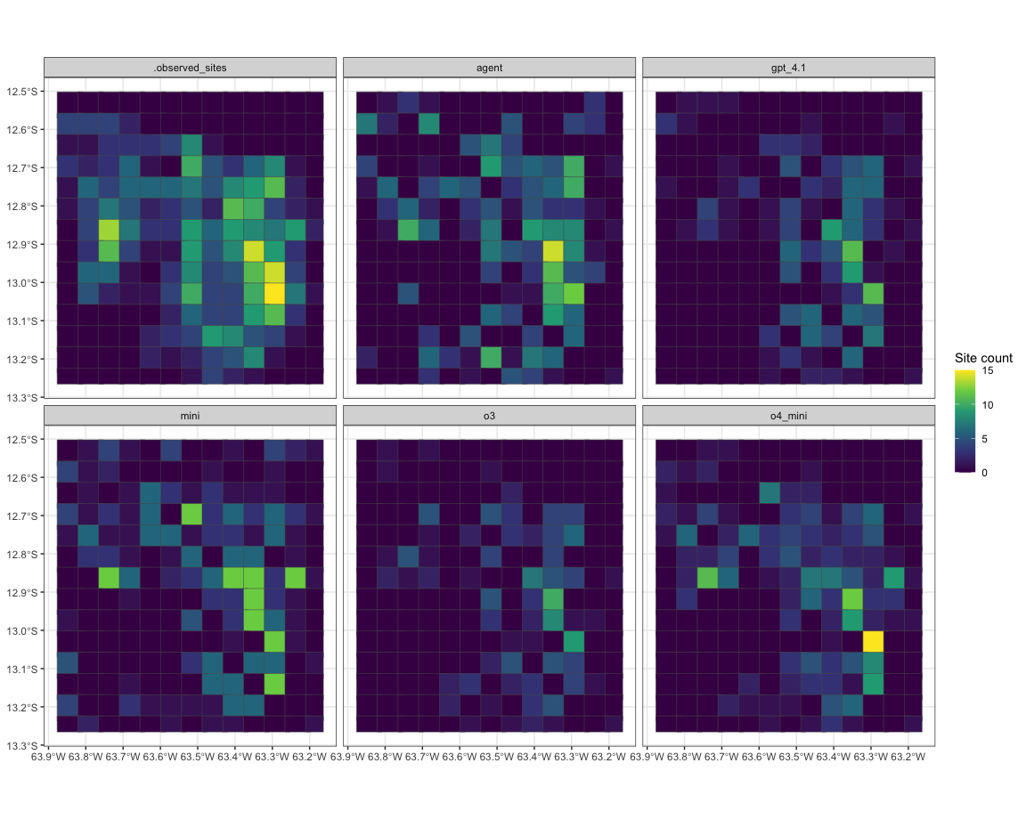

Source: [Article Notebook](https://nick-gauthier.github.io/itenez-anthrosols/index-preview.html)

Performance metrics for zero-shot site detection:

| model | accuracy | sens | spec | f_meas |
| --- | --- | --- | --- | --- |
| o4_mini | 0.742 | 0.672 | 0.873 | 0.773 |
| nano | 0.681 | 0.950 | 0.175 | 0.796 |
| agent | 0.670 | 0.613 | 0.778 | 0.709 |
| mini | 0.654 | 0.664 | 0.635 | 0.715 |
| gpt_4.1 | 0.637 | 0.513 | 0.873 | 0.649 |
| o3 | 0.615 | 0.454 | 0.921 | 0.607 |

Performance metrics for automated zero-shot site detection.

Source: [Article Notebook](https://nick-gauthier.github.io/itenez-anthrosols/index-preview.html)

Performance metrics for zero-shot site counting:

| model | rmse | mae | rsq |
| --- | --- | --- | --- |
| agent | 2.910 | 1.852 | 0.460 |
| o4_mini | 3.063 | 1.901 | 0.486 |
| mini | 3.097 | 2.143 | 0.413 |
| gpt_4.1 | 3.331 | 2.170 | 0.458 |
| o3 | 3.637 | 2.379 | 0.404 |
| nano | 3.813 | 2.703 | 0.072 |

Performance metrics for automated zero-shot site counting.

Source: [Article Notebook](https://nick-gauthier.github.io/itenez-anthrosols/index-preview.html)

Carson, John F, Francis E Mayle, Bronwen S Whitney, José Iriarte, and J Daniel Soto. 2016. “Pre-Columbian Ring Ditch Construction and Land Use on a ‘Chocolate Forest Island’in the Bolivian Amazon.” *Journal of Quaternary Science* 31 (4): 337–47.

De Souza, Jonas Gregorio, Denise Pahl Schaan, Mark Robinson, Antonia Damasceno Barbosa, Luiz E. O. C. Aragão, Ben Hur Marimon, Beatriz Schwantes Marimon, et al. 2018. “Pre-Columbian Earth-Builders Settled Along the Entire Southern Rim of the Amazon.” *Nature Communications* 9 (1): 1125. <https://doi.org/10.1038/s41467-018-03510-7>.

Denevan, William M. 1996. “A Bluff Model of Riverine Settlement in Prehistoric Amazonia.” *Annals of the Association of American Geographers* 86 (4): 654–81. <https://doi.org/10.1111/j.1467-8306.1996.tb01771.x>.

Erickson, Clark L. 2000. “An Artificial Landscape-Scale Fishery in the Bolivian Amazon” 408.

European Union/ESA/Copernicus. 2017. “Harmonized Sentinel-2 MSI: MultiSpectral Instrument, Level-2A (SR).” Google Earth Engine. <https://developers.google.com/earth-engine/datasets/catalog/COPERNICUS_S2_SR_HARMONIZED>.

Goldberg, Samuel L., Morgan J. Schmidt, Joshua D. Himmelstein, Michael Heckenberger, Bruna Franchetto, Helena Lima, Jennifer Watling, et al. 2024. “Widespread Amazonian Dark Earth in the Xingu Indigenous Territory.” *Nature Sustainability* 7 (10): 1304–12. <https://doi.org/10.1038/s41893-024-01399-3>.

Heckenberger, Michael J., J. Christian Russell, Carlos Fausto, Joshua R. Toney, Morgan J. Schmidt, Edithe Pereira, Bruna Franchetto, and Afukaka Kuikuro. 2008. “Pre-Columbian Urbanism, Anthropogenic Landscapes, and the Future of the Amazon.” *Science* 321 (5893): 1214–17. <https://doi.org/10.1126/science.1159769>.

Palace, M. W., C. N. H. McMichael, B. H. Braswell, S. C. Hagen, M. B. Bush, E. Neves, E. Tamanaha, C. Herrick, and S. Frolking. 2017. “Ancient Amazonian Populations Left Lasting Impacts on Forest Structure.” *Ecosphere* 8 (12): e02035. <https://doi.org/10.1002/ecs2.2035>.

Peripato, Vinicius, Carolina Levis, Guido A. Moreira, Dani Gamerman, Hans Ter Steege, Nigel C. A. Pitman, Jonas G. De Souza, et al. 2023. “More Than 10,000 Pre-Columbian Earthworks Are Still Hidden Throughout Amazonia.” *Science* 382 (6666): 103–9. <https://doi.org/10.1126/science.ade2541>.

Prümers, Heiko, Carla Jaimes Betancourt, José Iriarte, Mark Robinson, and Martin Schaich. 2022. “Lidar Reveals Pre-Hispanic Low-Density Urbanism in the Bolivian Amazon.” *Nature* 606 (7913): 325–28.

Prümers, Heiko, Carla Jaimes Betancourt, and Ruden Plaza Martinez. 2023. “Algunas tumbas prehispánicas de Bella Vista, Prov. Iténez, Bolivia.” *Zeitschrift für Archäologie Außereuropäischer Kulturen*, August, 251284 Seiten. <https://doi.org/10.34780/AKD6-046J>.

Robinson, Mark, Carla Jaimes-Betancourt, Sarah Elliott, S. Yoshi Maezumi, Lautaro Hilbert, Daiana Alves, Jonas Gregorio De Souza, and José Iriarte. 2021. “Anthropogenic Soil and Settlement Organisation in the Bolivian Amazon.” *Geoarchaeology* 36 (3): 388–403. <https://doi.org/10.1002/gea.21839>.

Schmidt, Morgan J., Anne Rapp Py-Daniel, Claide De Paula Moraes, Raoni B. M. Valle, Caroline F. Caromano, Wenceslau G. Texeira, Carlos A. Barbosa, et al. 2014. “Dark Earths and the Human Built Landscape in Amazonia: A Widespread Pattern of Anthrosol Formation.” *Journal of Archaeological Science* 42 (February): 152–65. <https://doi.org/10.1016/j.jas.2013.11.002>.

Wagner, Fabien H, Ricardo Dalagnol, Griffin Carter, Mayumi CM Hirye, Shivraj Gill, Le Bienfaiteur Sagang Takougoum, Samuel Favrichon, et al. 2025. “High Resolution Tree Height Mapping of the Amazon Forest Using Planet NICFI Images and LiDAR-Informed u-Net Model.” <https://arxiv.org/abs/2501.10600>.